Manilla App Design   
Project Plan

Spring Break

#### Readings

**Review (pls pls do)**

* UX Design Basics:
  + [What is the difference between ui and ux design?](https://uxplanet.org/what-is-ui-vs-ux-design-and-the-difference-d9113f6612de)
  + [The magic of paper prototyping](https://uxplanet.org/the-magic-of-paper-prototyping-51693eac6bc3)
  + [A complete list of UX design deliverables](https://uxplanet.org/a-complete-list-of-ux-deliverables-d62ccf1de434)

**Chill n relax**

* ^
* Get ready to start moving faster w project.

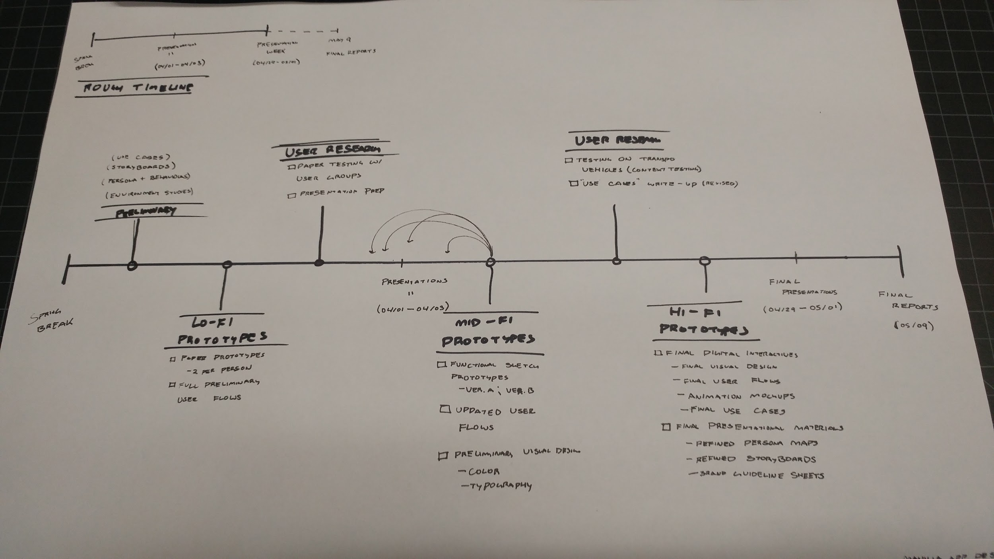

Week of 03/18(M) to 03/22(F)

#### Preliminary Research

**Lit Review**

<https://docs.google.com/document/d/1aO15KZbjZhEL3IGL41NoHAZT44-_LZDgaoP3F2dXgxE/edit>

Keep track of the existing studies about traffic research, app design, modes of communication.

[**Use Cases**](https://docs.google.com/document/d/1LIAbja7OR7hn9EolDp2p4I3cU90QJ7T7rN68kHXLGnU/edit?usp=sharing) **(ARI, ISADORA)**

* Outlines, from a user’s point of view, an app’s behavior as it responds to a request. Each use case is represented as a sequence of simple steps, beginning with a user’s goal and ending when that goal is fulfilled.
* What we need in each use case:
  + What the user is trying to do: (i.e. search for cheapest transit)
  + Actor/persona: (i.e. low-income gov. worker)
  + Steps user has to take in app

**Persona + Behaviour charts (JULIE, JUNWOO)**

* Represents user types through fictional characters. Illustrates a group of users who use a product in a similar way. Helps you understand user context, behaviours, motivations, and pain points.
* What personas we need:
  + Low income province-to-city laborer.
  + Mid income outer-city government worker
  + Researcher on CMU team giving feedback
* What each persona map needs:
  + Age
  + Occupation
  + Income
  + Motivation
  + Goals
  + T.B.A

**Vehicle Chart (ROBERT)**

* Contexts can change how the

**Storyboards (TBD Wednesday...)**

* Translate functionalities into real-life situations. Illustrates a series of actions that users need to take while using the product.
* What we need in storyboard:
  + One participant persona
  + One researcher persona
  + Use case + environmental context

Week of 03/25 to 03/29 //Meet with Noah on Wed?

#### Lo-Fi Prototypes

**Paper prototypes (five iterations total)**

* At this stage, we’re rapidly prototyping screens and user flows to explore a variety of different ideas and their pros and cons.
* What we need:
  + One (1) paper prototype per person.
  + User flow diagrams for each paper prototype
* What needs to be in each paper prototype:
  + Sign-in screen
  + Onboarding screens
  + Home menu / dashboard screens
  + Research questions screens
  + Researcher feedback screens
  + Map screens
* Questions to get started:
  + What should be said during the onboarding process?
  + What features should be on the dashboard?
  + Where/How should users input their emotions?
  + How should users talk about their motivations?
  + Where/How do users see inputs from other users?
  + How do users and researchers talk to each other?

#### User Research I

**Paper testing**

* Test with others (doesn’t matter who) to see if paper prototypes communicate a user flow that makes sense.

#### Presentation II

**Preliminary Research**

* Use Cases
* Persona + Behaviour charts
* Storyboards

**Paper Prototypes feedback**

* Photos of our paper prototypes
* Feedback given to us by our testers

**Next Steps:**

* Mid-fi prototype (functional digital interaction)
* Updated user flows

Week of 04/01 to 04/05 -- PRESENTATION II

#### Mid-Fi Prototypes

**Digital prototypes (two iterations)**

* At this stage, we’re taking the pros of each of our iterations and prototyping two digital iterations on Sketch to test our screens irl.
* What we need:
  + Version A of digital prototype
  + Version B of digital prototype
  + User flows for Version A and Version B
  + Preliminary visual design
    - Typography
    - Color swatches
    - Ideas for image/illustration use
* What needs to be in each digital prototype:
  + Sign-in screen
  + Onboarding screens
  + Home menu / dashboard screens
  + Research questions screens
  + Researcher feedback screens
  + Map screens

Week of 04/08 to 04/12 //Meet with Noah on Wed??

#### User Research II

**Digital testing (AB Testing)**

* User testing on different types of transit environments to identify possible issues with using the digital prototype while moving from point A to point B.
* Check typography, color, contrast.
* Check ability to perform actions such as swiping, tapping
* Record feelings of awkwardness/okay-ness while using app on public transit.

Week of 04/15 to 04/19

#### Hi-Fi Prototype I

**Final prototype week one progress**

* At this stage, we’re taking everything we’ve learned from the past stages and bringing them together to create one cohesive final iteration.
* What we need for our digital prototype:
  + Hand-drawn versions of final screens for us to replicate on Sketch
  + Progress on final digital sketch interactives.
  + Progress on AfterEffects animated mockup.
  + Progress on final user flows
  + Final use cases
  + Progress on final visual design decisions
    - Typography stylesheets
    - Color stylesheets
    - Images/Illustrations
* What extra stuff we need for our final presentation:
  + Progress on refined persona maps
  + Progress on refined storyboards

Week of 04/22 to 04/26

#### Hi-Fi Prototype II

**Final prototype week two progress**

* At this stage, we’re taking everything we’ve learned from the past stages and bringing them together to create one cohesive final iteration.
* What we need for our digital prototype:
  + Final digital sketch interactive.
  + Final AfterEffects animated mockup
  + Final user flow
  + Final use cases
  + Final visual design decision
    - Typography stylesheets
    - Color stylesheets
    - Images/Illustrations
* What extra stuff we need for our final presentation:
  + Final refined persona maps
  + Final refined storyboards
  + In-context, IRL Mockup video

Week of 04/29 to 05/03 -- FINAL PRESENTATION

Week of 05/06 to 05/10 -- FINAL REPORT